**JSS - 1001 Career Ready Video Reflection Assignment (20%)**

Student Name: Student Number:

**Objective:** Reflect on the content shared in the course and assess where you are now, where you want to be, and what needs to happen in order to get there. Reflection is an important tool for self-assessment and practice improvement.

**What? So What? Now What? Framework:**

When reflecting, please consider asking yourself the following. What am I reflecting on, what is the impact, how do I feel about it and what have I learned and what improvements will I make as a result/action of this opportunity to reflect?

**Instructions:**

* Allow yourself time to reflect on the questions below.
* Remember there are no wrong answers, the importance is to allow yourself to be open and honest and describe what you feel when reflecting on these different areas of your life.
* Reflection requires you to be willing to be vulnerable, recognize and acknowledge things about yourself - it is not always easy, but it is helpful.
* The personal reflection must be unique to you, only you can be you!
* The reflection must include thoughts and observations about all the reflection questions.

**Format Requirements:**

You are asked to record yourself on video. How you do this is up to you. If you feel more comfortable narrating a slide presentation while sharing your reflection, please do so. At a minimum, you should be using some visual cues to help guide your audience through your reflection. It is mandatory to have your camera on in the video. Non-verbal cues are important elements of reflection.

**Reflection Video length: The video should not exceed 3 minutes.**

Format Checklist:

* + Tell a story!
  + Avoid question/answer style – build a smooth transition between each section
  + Camera on during video reflection
  + Video length cannot exceed 3 minutes.
  + Clear audio and visuals
  + Smooth transition and use of supporting visuals.
  + Ensure video access can be easily shared with your professor.
  + Control the environment (don’t record in a car, at work etc.). Remember this is a professional assessment.

**Reflection Questions:**

1. What is your ultimate career goal?
2. How will you use your current skills to attain your career goal?
3. What is one thing that you would like to improve on to help achieve your career goal, and why?
4. How do you consider/evaluate your job search and networking efforts to date? What can you do to become more successful at it?
5. What are your personal growth opportunities for the next year? Please be specific and try to quantify.

**Submission Instructions:**

* + Please upload the reflection to Moodle by the specified date

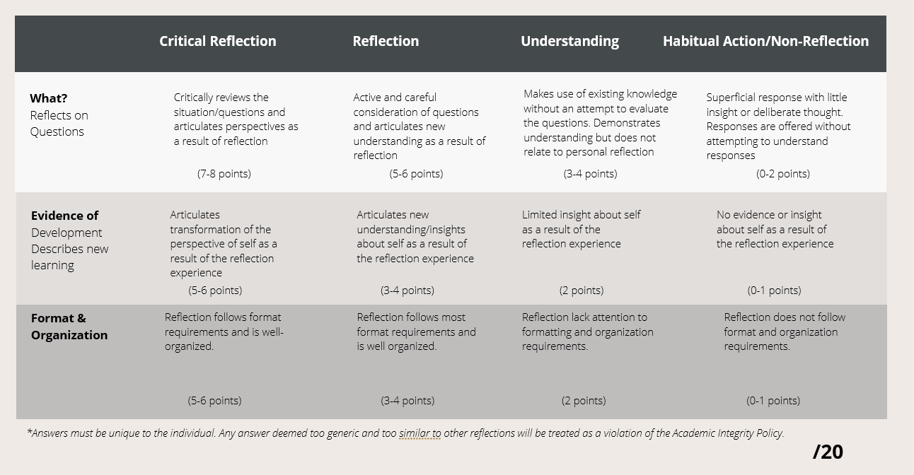

***Please note: This is an individual activity and reflects an individual career goal. Answers must be unique to the individual. Any answer deemed too generic and too similar to other reflections will be treated as a violation of the Academic Integrity Policy.***